**Introduction to Google Drive**

You can use Google Drive to create, organize, transfer, and share files.

To create a new file, select  then select file that you want to create.

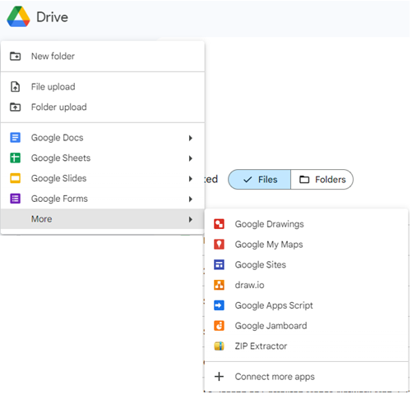

To navigate Google Drive, you use the tools built into the web interface to find, store and retrieve, upload and download files, and share them with others.

Search for a file or filter search results.

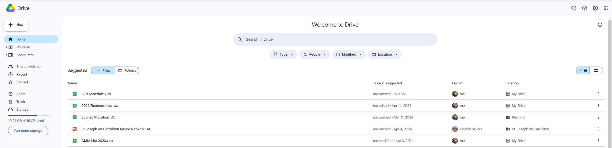

Navigation Menu. Used to locate files in Google Drive. Storage Management.

**Upload a File to Google Drive (Windows 11)**

1. Open <https://drive.google.com>.
2. Select, then click **File Upload**.

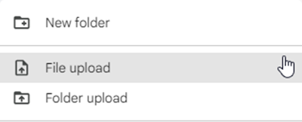

1. Navigate to file path of document to be uploaded.
   1. To upload multiple files, press **Ctrl**, then click on any other files.
2. Click **Open**.

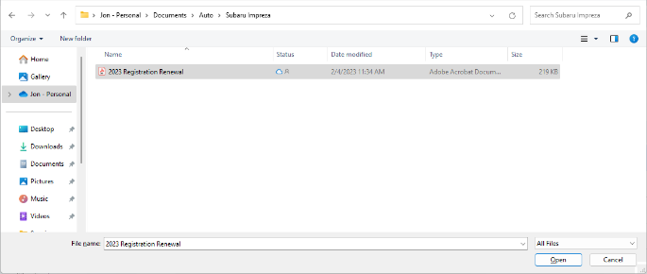

1. Upload Details are visible in the bottom right.



1. To View the file(s) detail, organize, and share, click on the sandwich menu in the **Sorting Options** column.

